23/01/2024
Student Records Management System
School guide for online Year 11 equivalent studies applications: international
Acknowledgement of Country
Kaya. The School Curriculum and Standards Authority (the SCSA) acknowledges that our offices are on Whadjuk Noongar boodjar and that we deliver our services on the country of many traditional custodians and language groups throughout Western Australia. The SCSA acknowledges the traditional custodians throughout Western Australia and their continuing connection to land, waters and community. We offer our respect to Elders past and present.
Copyright
© School Curriculum and Standards Authority, 2023
This document – apart from any third-party copyright material contained in it – may be freely copied, or communicated on an intranet, for non­commercial purposes in educational institutions, provided that the School Curriculum and Standards Authority (the SCSA) is acknowledged as the copyright owner, and that the SCSA’s moral rights are not infringed.
Copying or communication for any other purpose can be done only within the terms of the Copyright Act 1968 or with prior written permission of the SCSA. Copying or communication of any third-party copyright material can be done only within the terms of the Copyright Act 1968 or with permission of the copyright owners.
Any content in this document that has been derived from the Australian Curriculum may be used under the terms of the Creative Commons Attribution 4.0 International licence.
School Curriculum and Standards Authority
Street address: 303 Sevenoaks Street CANNINGTON WA 6107
Postal address: PO Box 816 CANNINGTON WA 6987
Phone: +61 8 9273 6300
General email: info@scsa.wa.edu.au
Web: www.scsa.wa.edu.au
Cover photo credit: PeopleImages via iStock
Contents
Online Year 11 equivalent studies applications 1
Application timelines 1
Five steps for school administrator submission 2
Step 1: Log in to the SRMS portal 2
Step 2: Create a Year 11 equivalent studies application 3
Step 3: Upload supporting documents 8
Step 4: Submit a Year 11 equivalent studies application 9
Step 5: Amend a Year 11 equivalent studies application 10
Three steps for principal or deputy principal certification 13
Step 1: Log in to the SRMS portal 13
Step 2: View and certify a Year 11 equivalent studies application 14
Step 3: Certify an amended Year 11 equivalent studies application 16

Online Year 11 equivalent studies applications
Schools may enrol a student in Year 12 if they consider that studies completed elsewhere indicate that the student has achieved the equivalent of Year 11 studies.
Schools should complete an online application for Year 11 equivalent studies for a Western Australian Certificate of Education (WACE). This applies to students who:
- are transferring into the WACE program at the start of a semester and who have completed the equivalent of one semester of Year 11 in Western Australia; or
- have completed studies at an international or interstate institution or through training equivalent to the completion of Year 11 in Western Australia.
This user guide is for school administrators who will create and submit a Year 11 equivalent studies application via the Student Records Management System (SRMS) portal and the principal or deputy principal who will certify the documentation to support this application.
The School Curriculum and Standards Authority (the SCSA) considers all applications submitted by schools through the SRMS portal.
If you have any queries about the online Year 11 equivalent studies application, contact the SCSA’s Data Services team at dataservices@scsa.wa.edu.au.

Application timelines
Schools may complete a Year 11 equivalent studies application for students in Year 11 or Year 12.
The SCSA will process applications for current Year 12 students up to Friday, 8 November 2024. After this date, the Student Information Records System (SIRS) database will be locked and will not accept any Year 12 achievements.
The SCSA will process semester-long applications for current Year 11 students after Semester 1 has finished.
The SCSA will process year-long applications for current Year 11 students, but these are not finalised until the students are registered in Year 12.
These applications for current Year 11 students will remain in Pending Year 12 registration status until the students are registered in Year 12, when they will update to Approved status and the block credit will be applied to SIRS.

Five steps for school administrator submission

Step 1: Log in to the SRMS portal
Log in to the SRMS portal (https://srms.scsa.wa.edu.au).
The first time you log in, click on and read the login instructions (highlighted below). Contact your school administrator if you have not received the email with the link.
Enter your work email address and password in the non-government school login panel.
Tick the check box (highlighted below) to show that you have read and understand the terms of use.
Click on the Login button (highlighted below) to enter the SRMS portal.
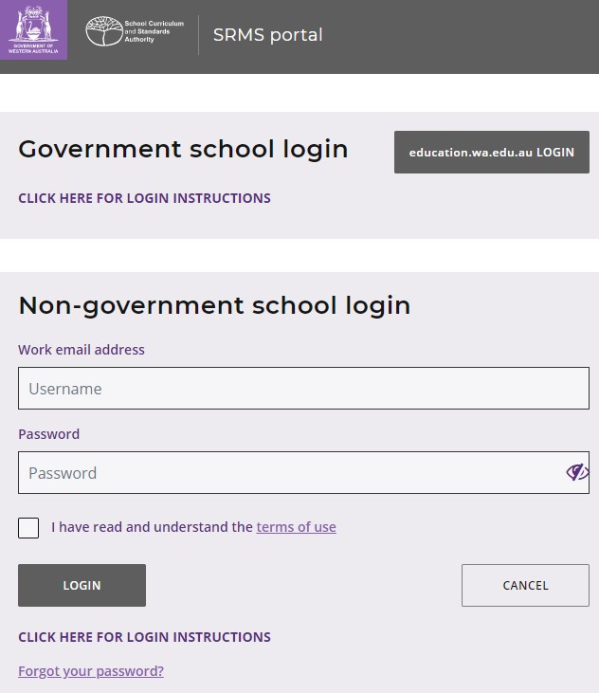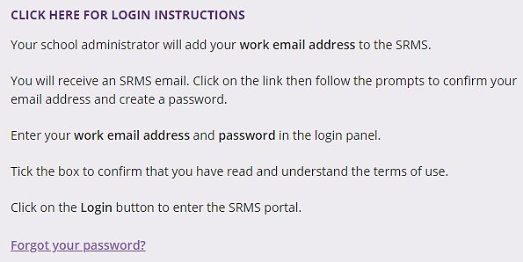

If you forget your password, click on Forgot your password.
Enter your work email address and tick the check box to confirm that you are not a robot. You will be prompted to select images as part of the verification process, and then you can choose another password.

Step 2: Create a Year 11 equivalent studies application
To create a Year 11 equivalent studies application, click on the Equivalent Studies tab and select Create Equivalent Studies Application from the drop-down list (highlighted below).
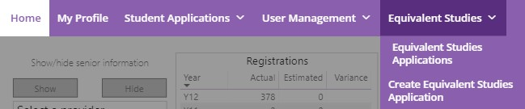
All students in Years 11 and 12 will be displayed in alphabetical order on the screen. Search through the alphabetical list to find the student who requires a Year 11 equivalent studies application.
Alternatively, search for that student with the Filter students function (highlighted below). Type in the student’s Given Name and/or Family Name, or their WA Student Number, then click on the Search button (highlighted below) to select that student’s details.
When you have selected the correct student, click on the Create button (highlighted below) next to that student’s details.
Note: to rearrange the order of students’ names displayed on the screen, click on the arrow (highlighted below) next to Family Name.
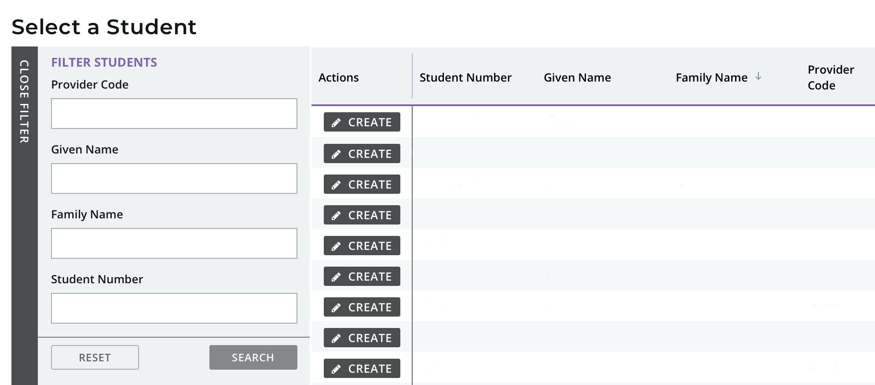
Click on the arrows at the bottom of the screen to navigate from one page to the next.
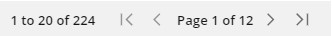
If the student already has block credit of one semester or one full year of Year 11 equivalent studies, you will see the warning below and will not be able to start an application.
Refer to the SIRS report CSE136 to confirm how much block credit has been granted to the student.
You will see the Year 11 equivalent studies for a Western Australian Certificate of Education (WACE): Completion of the equivalent of senior secondary studies introduction on the screen. Click on the Next button, then click on the Next button again to start an application. Complete all four sections of the application.
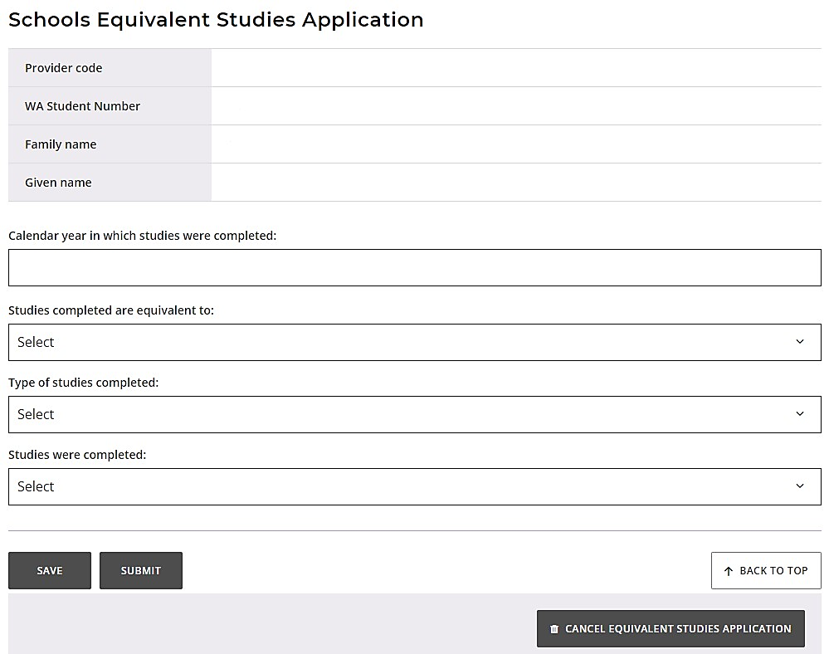
Calendar year
Type in the calendar year in which the studies were completed.
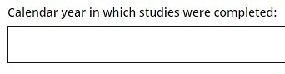
Length of time
Select the length of time the studies are equivalent to from the drop-down list, i.e. One semester (Certificate II) or Whole year (Certificate III or above).
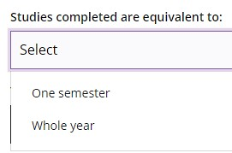
Type of Year 11 equivalent studies
Select the type of Year 11 equivalent studies completed from the drop-down list, i.e. VET,
VET: Apprenticeship/Traineeship or Secondary Education.
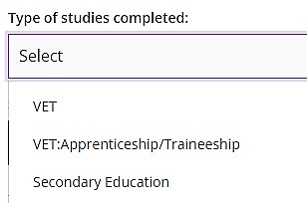
Where the Year 11 equivalent studies were completed
Select where the Year 11 equivalent studies were undertaken from the drop-down list, i.e. International (outside Australia), Interstate (within Australia), Other (specify) or Through an RTO.
If you select Other (specify), you must provide details for consideration by the SCSA.
The Authority will recognise the completion of the Year 11 International Baccalaureate (IB) Diploma Programme as credit for Year 11 equivalent studies and this will contribute to meeting the WACE requirements where students transfer to the WACE program in Year 12.
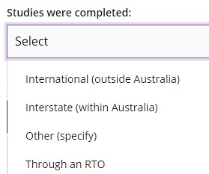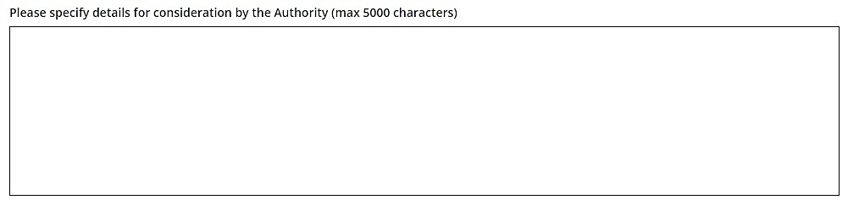
If you select International (outside Australia), Interstate (within Australia) or Other (specify), click on the Submit button (highlighted below) to submit the application. These Year 11 equivalent studies applications do not require any supporting documents.
If you would like to save the application and complete it later, click on the Save button (highlighted below).
If you decide to cancel the application, click on the Cancel equivalent studies application button (highlighted below).
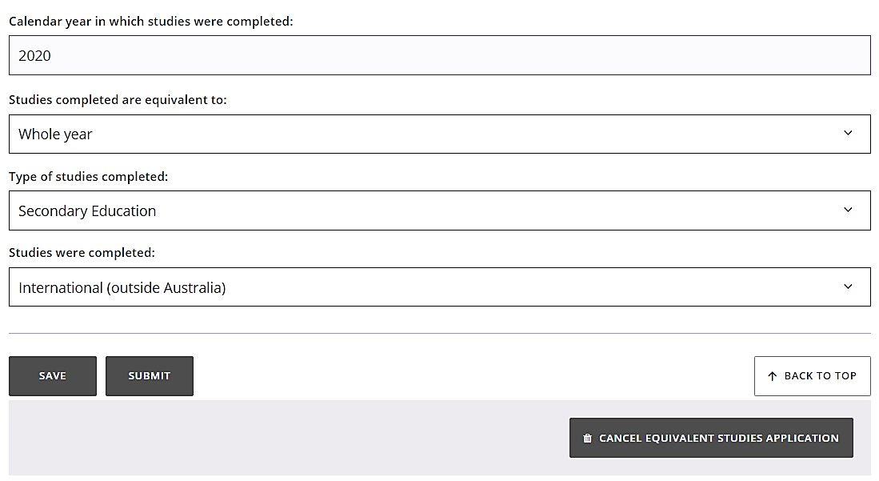

If the student completed their Year 11 equivalent studies at a registered training organisation (RTO), enter the RTO provider code or name in the RTO field (highlighted below). As you type, a predictive drop-down list of RTOs that include those numbers or letters (minimum two numbers or letters) will appear. Select the correct RTO from the drop-down list.
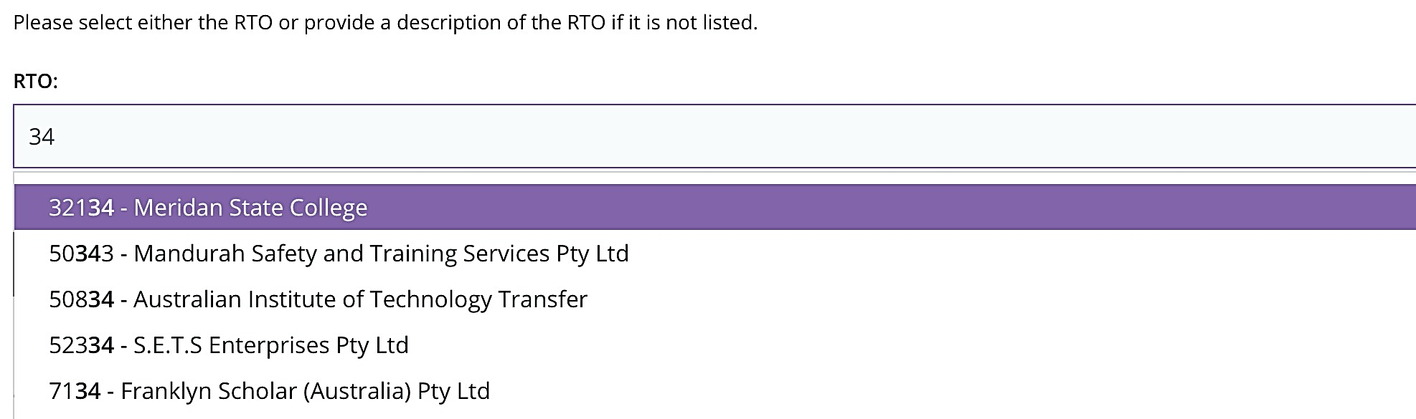
If you do not see the RTO listed, type the RTO’s name and/or code in the RTO description: Name and/or code field (highlighted below).
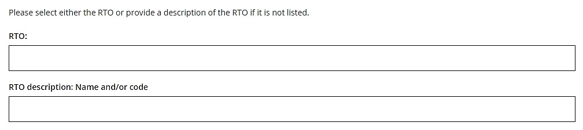
Qualifications
Select the qualification code from the Qualification field (example shown below). As you type, a predictive drop-down list of qualification codes that include those numbers or letters will appear. Select the correct qualification from the drop-down list.
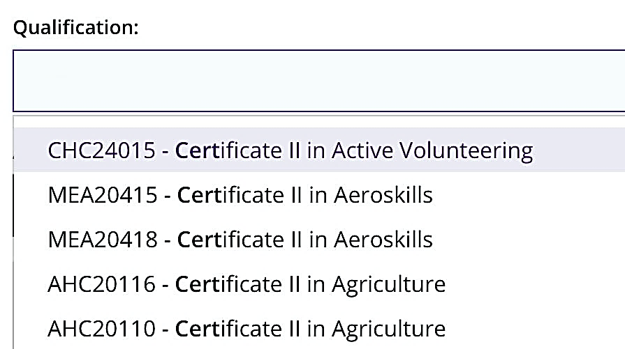
You can search for the correct qualification using the terms Certificate, II, III, IV, or diploma, or keywords, such as automotive, construction, data, fashion, health, hospitality, media or retail (example shown below).
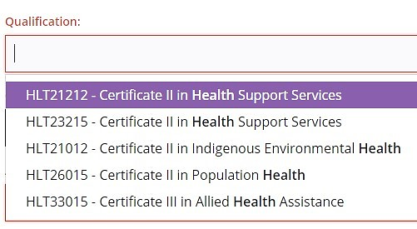
If you do not see the qualification code in the drop-down list, type the name and/or code in the Qualification: Name and/or code field (highlighted below).
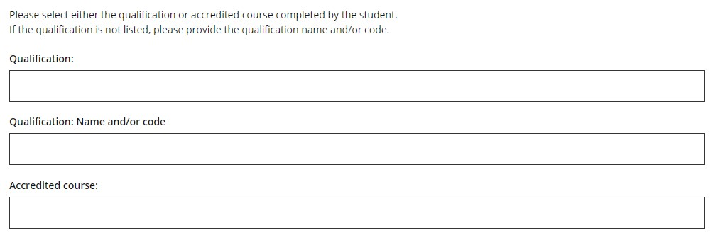
Accredited courses
Select the accredited course code from the Accredited course field (example shown below).
As you type, a predictive drop-down list of accredited course codes that include those numbers or letters will appear. Select the correct accredited course from the drop-down list.
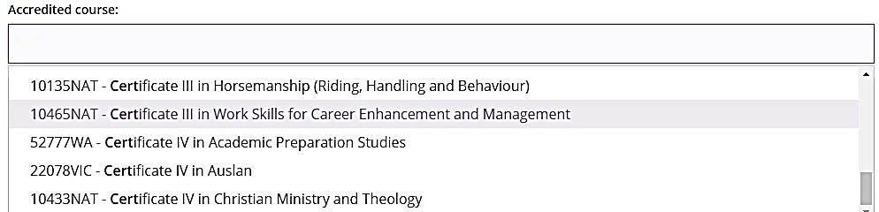

Step 3: Upload supporting documents
Click on the Select document type button (highlighted below) to see a list of required documents to support the student’s Year 11 equivalent studies application.
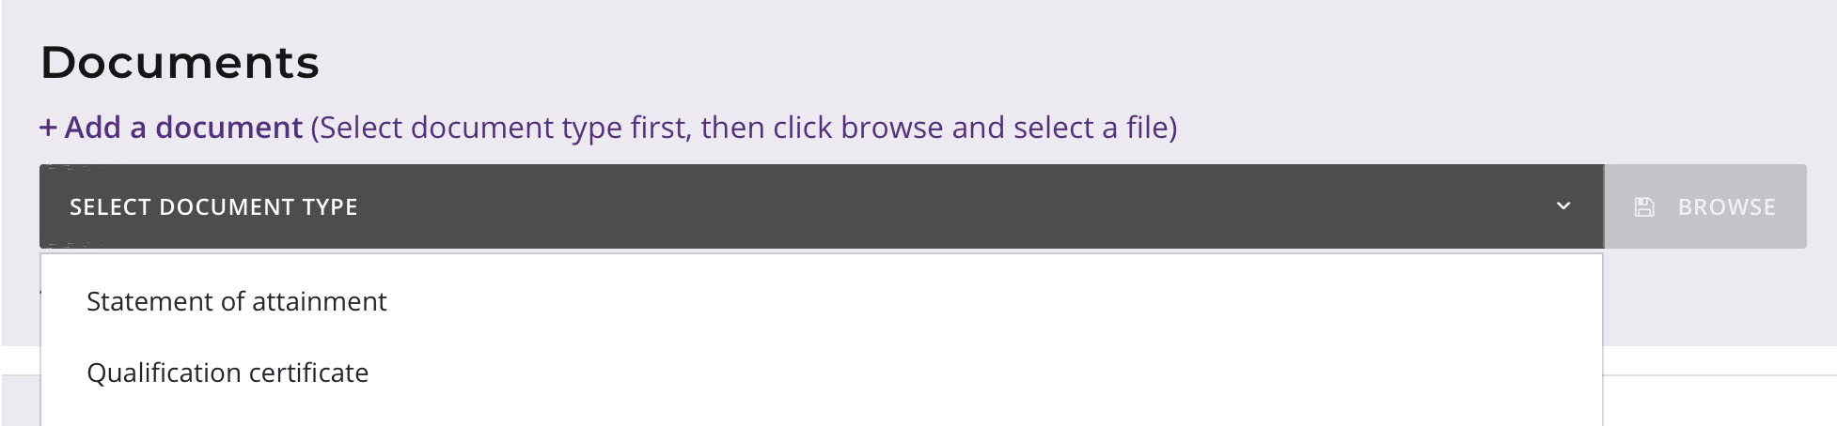
You must provide a Statement of attainment and a Qualification certificate to support each Year 11 equivalent studies application achieved through an RTO.
Photograph or scan each document and save the files to your computer. Your supporting documents must be saved as .pdf, .jpg, .jpeg or .png files, with a maximum size of 4MB for each file. Word documents will not be accepted.
Select the first file you wish to upload from the drop-down list (highlighted below). Click on the Browse button (highlighted below) to select the first file from your computer, and then click on the Open button (Choose button on a Mac) to upload this file.
Repeat this process to upload the second file.
If you do not upload both required documents, you will not be able to proceed to Step 4: Submit Year 11 equivalent studies application.
Click on the Save button (highlighted below) if you decide to submit the application later.
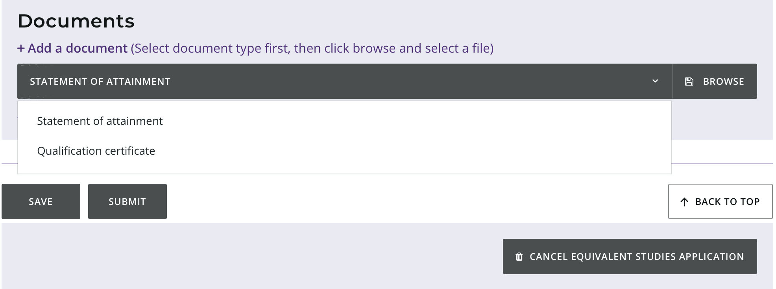

Step 4: Submit a Year 11 equivalent studies application
Click on the Submit button (highlighted below) to submit the student’s Year 11 equivalent studies application.
You will see a warning, asking if you are sure you want to complete the application.
Click on the Yes button (highlighted below) to submit this application or on the No button if you do not want to proceed.
Click on the Cancel equivalent studies application button (highlighted below) if you decide not to continue with this application.
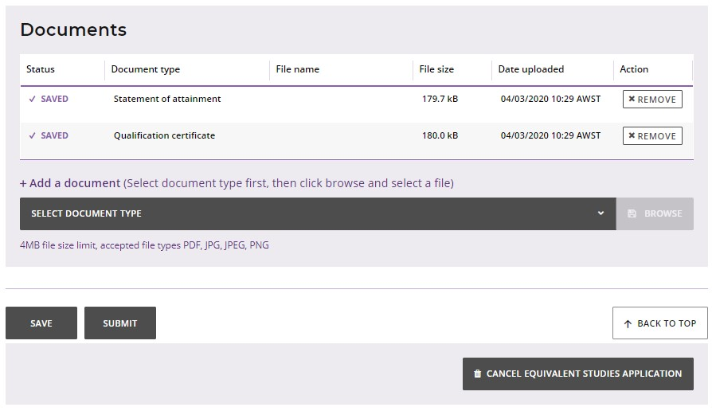
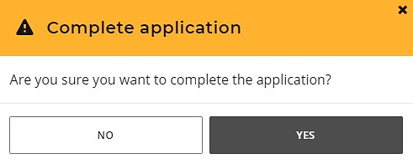
You will return to the Schools Equivalent Studies screen.
After submission, your principal or deputy principal will certify the student’s application.
The SCSA will decide whether to approve the student’s application or not, or if any amendments are required.

Step 5: Amend a Year 11 equivalent studies application
If the SCSA requires any amendments to a student’s application, you will see Amend application in the Status column on the Schools Equivalent Studies screen (highlighted below).
The Requires attention by me column will show as Yes (highlighted below), advising you to act.
Click on the View button (highlighted below) to see the required amendment/s.
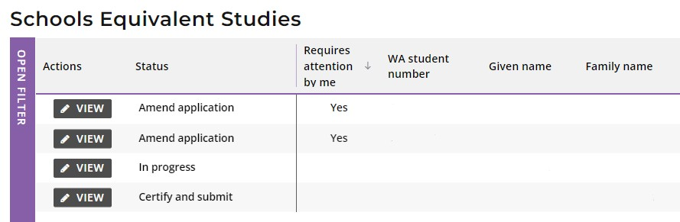
You will only be able to change the information identified by the SCSA, which will be highlighted in yellow (example below) with instructions about what to amend.
Select the correct response from the drop-down list for the section highlighted, then click on the Submit button (highlighted below).
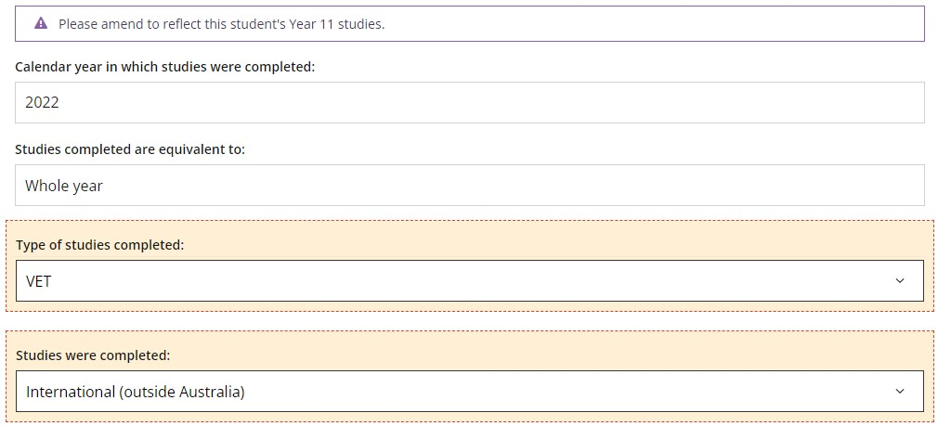
If the SCSA requires an amendment to a student’s application for studies completed at an RTO, the highlighted areas will include the RTO provider details, the Qualification code or Accredited course code and your supporting documents. You may be required to amend one or more fields.
To edit a field, clear your previous response then either select the correct response from the
drop-down list in that field, or move to a different field to enter the correct details.
For example, if you had chosen Qualification by mistake, clear this response, then enter the correct Accredited course code in the Accredited course field.
As you type, a predictive drop-down list of responses will appear. Select the correct response for that field from the drop-down list.
Remove any supporting documents by selecting the Remove button (highlighted below), then follow Step 3 to upload the correct document/s.
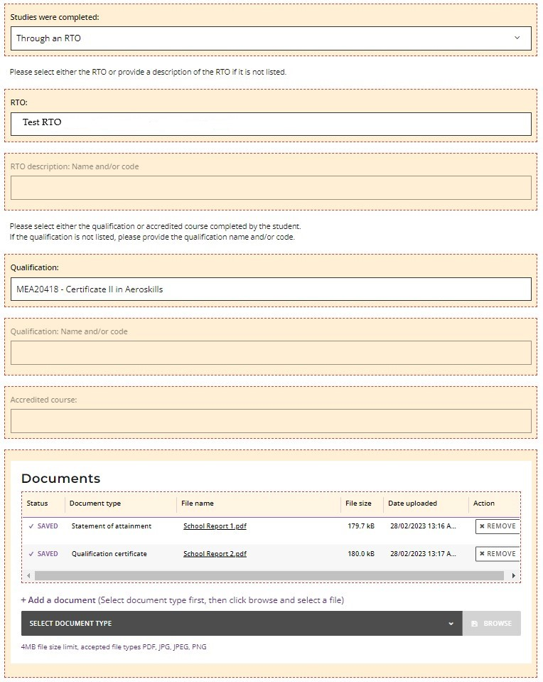
When you have amended the information and/or uploaded a new document/s, as requested, then click on the Submit button (highlighted below) to submit this additional information.
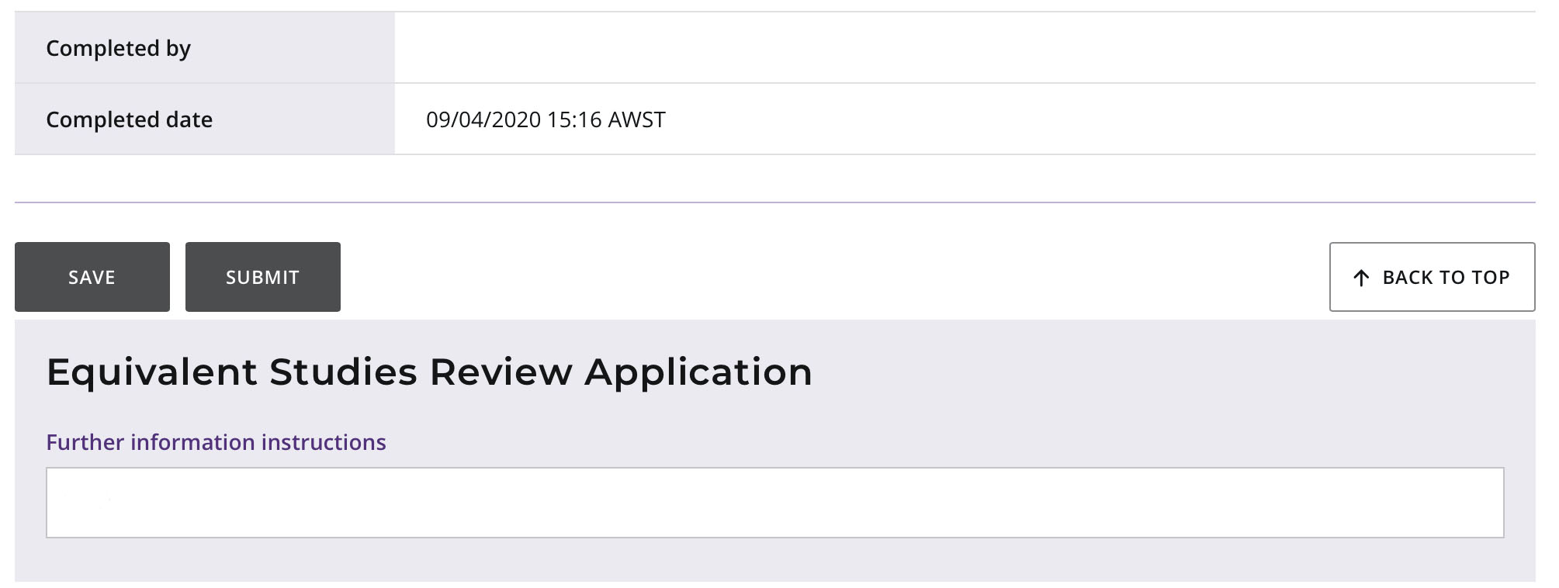
You will see a warning, asking if you are sure you want to complete the application.
Click on the Yes button (highlighted below) to submit this application or on the No button if you do not want to proceed.
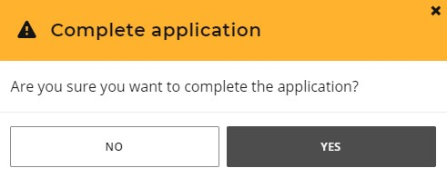
You will return to the Schools Equivalent Studies screen.
The Status column will say Certify and submit (highlighted below), which means that the application must be certified by your principal or deputy principal.
The Requires attention by me column will now be blank, to show that you have completed your amendment for that student’s application.
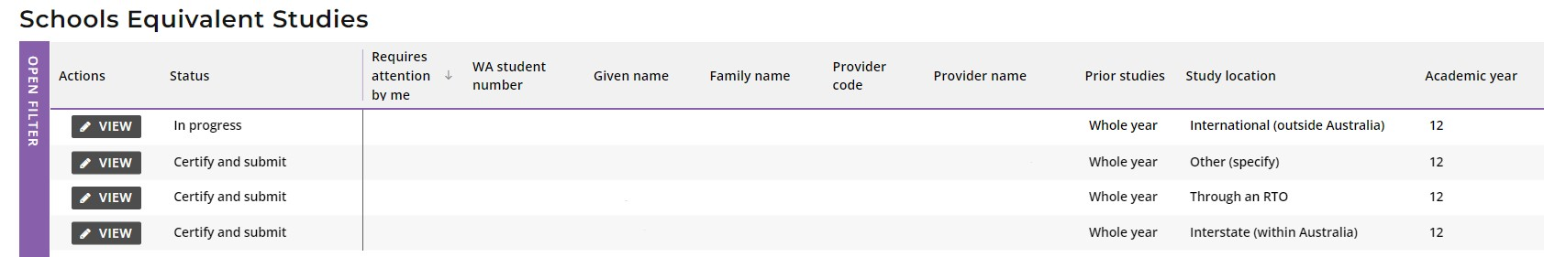
At any time, you can check the Schools Equivalent Studies screen to monitor the progress of students’ applications. Below are terms you will see throughout the online Year 11 equivalent studies application process that relate to the status of students’ applications.
Status of Year 11 equivalent studies applications
New | New application has been started but not submitted by the school administrator
Certify and submit | Application requires certification and submission by the school principal or deputy principal
Amend application | Application requires amendment by the school administrator
In progress | Application has been received by the SCSA and is waiting for review and approval
Approved | Application has been approved by the SCSA
Not approved | Application has not been approved by the SCSA, with an explanation for this determination
Pending Year 12 registration | Application for a current Year 11 student has been processed and will be finalised when the student is registered in Year 12
Cancelled | Application has been cancelled by the school or the Authority

Three steps for principal or deputy principal certification

Step 1: Log in to the SRMS portal
Log in to the SRMS portal (https://srms.scsa.wa.edu.au).
The first time you log in, click on and read the login instructions (highlighted below). Contact your school administrator if you have not received the email with the link.
Enter your work email address and password in the non-government school login panel.
Tick the check box (highlighted below) to show that you have read and understand the terms of use.
Click on the Login button (highlighted below) to enter the SRMS portal.

If you forget your password, click on Forgot your password.
Enter your work email address and tick the check box to confirm that you are not a robot. You will be prompted to select images as part of the verification process, and then invited to choose another password.

Step 2: View and certify a Year 11 equivalent studies application
Select Equivalent Studies Applications from the Equivalent Studies drop-down list (highlighted below).
You will see all submitted applications for your students on the Schools Equivalent Studies screen.
The Status column will show as Certify and submit and the Requires attention by me column will show as Yes, advising you to act.
Click on the View button (highlighted below) to check and certify that student’s application.
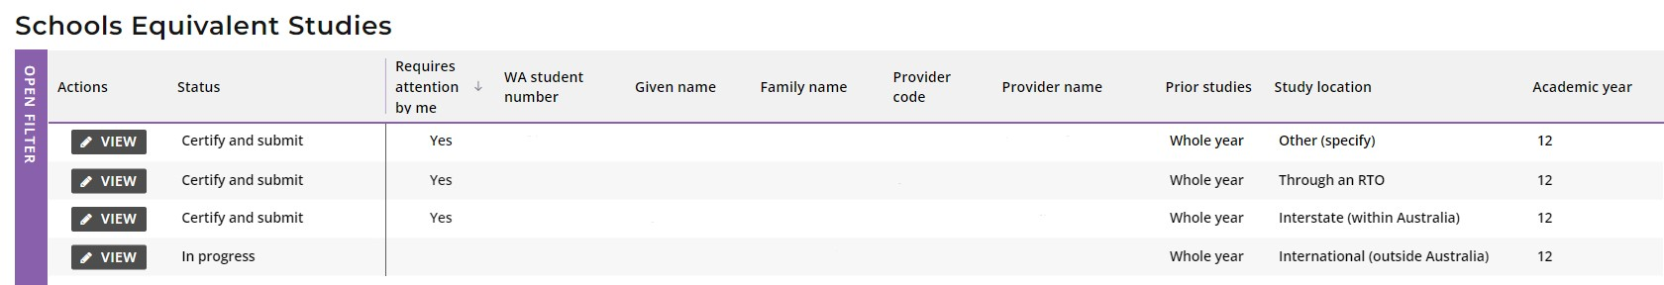
Scroll to the bottom of the application to the Equivalent Studies Certify Application section.
Tick the check box (highlighted below) to certify that you have seen the relevant documents and can verify that the student has undertaken studies equivalent to the completion of either a semester or whole year of Year 11 in Western Australia.
Click on the Submit button (highlighted below) to submit your certification of that student’s application.
Click on the Cancel equivalent studies application button (highlighted below) if you decide not to continue with this application.
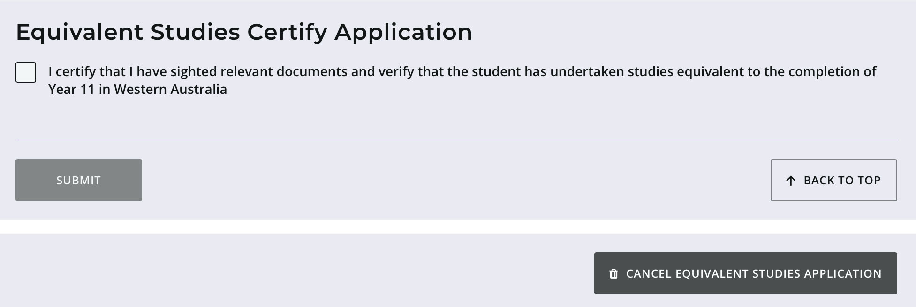
You will return to the Schools Equivalent Studies screen.
The Status column will show as In progress (highlighted below), which means that the application has been received by the SCSA.
The Requires attention by me column will be blank, indicating that you have completed certification of that student’s application.
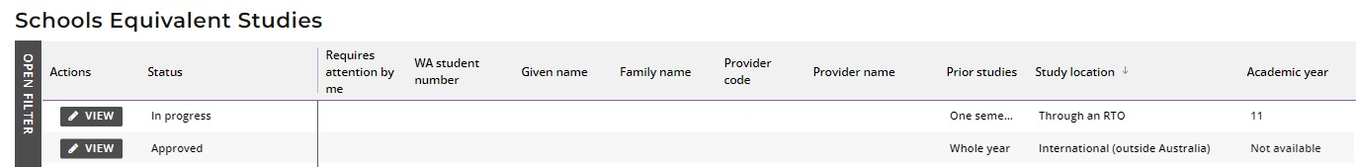
At any time, you can check the Schools Equivalent Studies screen to monitor the progress of students’ applications.
Below are terms you will see throughout the online Year 11 equivalent studies application process that relate to the status of students’ applications.
Status of Year 11 equivalent studies applications
New | New application has been started but not submitted by the school administrator
Certify and submit | Application requires certification and submission by the school principal or deputy principal
Amend application | Application requires amendment by the school administrator
In progress | Application has been received by the SCSA and is waiting for review and approval
Approved | Application has been approved by the SCSA
Not approved | Application has not been approved by the SCSA, with an explanation for this determination
Pending Year 12 registration | Application for a current Year 11 student has been processed and will be finalised when the student is registered in Year 12
Cancelled | Application has been cancelled by the school or the Authority
The SCSA will decide whether to approve each student’s application or not, or if any amendments are required.

Step 3: Certify an amended Year 11 equivalent studies application
If the SCSA requires any amendment/s to a Year 11 equivalent studies application from a student at your school, this will be done by the school administrator. You must then certify and submit the amended application.
You will see any amended applications on the Schools Equivalent Studies screen.
The Status column will say Certify and submit and the Requires attention by me column will say Yes, advising you to act.
Click on the View button (highlighted below) to certify that student’s amended application.
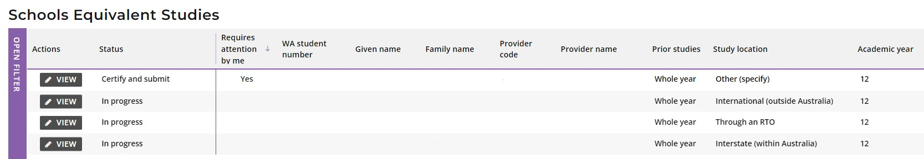
Scroll to the bottom of the application to the Equivalent Studies Certify Application section.
Tick the check box (highlighted below) to certify that you have seen the relevant documents and can verify that the student has undertaken studies equivalent to the completion of either a semester or whole year of Year 11 in Western Australia.
Click on the Submit button (highlighted below) to submit your certification of that student’s amended Year 11 equivalent studies application.
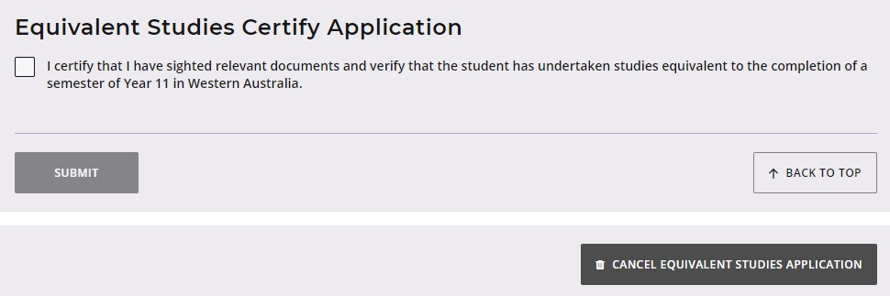
You will return to the Schools Equivalent Studies screen.
The Status column will show as In progress and the Requires attention by me column will now be blank to show that you have completed your certification of that amended Year 11 equivalent studies application.

